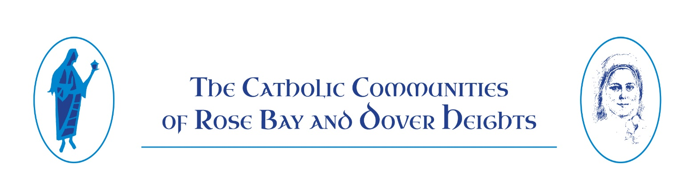

Dear St. Mary Magdalene and St. Therese Lisieux Parishioner.

We welcome you to our Rose Bay and Dover Heights Catholic Communities, to best serve your needs we kindly ask you to complete the following registration form and present to the Parish office once completed.
The Parish takes all reasonable precautions to safeguard your personal information from loss, misuse, interference, unauthorised access, modification or unlawful disclosure.

Our Privacy statement can provide you with further information should you have any concerns, please feel free to contact the Parish office for any further assistance.
However, you should keep in mind that the transmission of information over the internet is not completely secure or error-free. In particular, e-mail sent to or from this Site may not be secure, and you should therefore take special care in deciding what information you send to us via e-mail.

Please Print Clearly
Surname |  |  | Occupation
Christian Names |  |  | Home Phone
Marital Status |  |  | Mobile Phone
Date of Birth |  |  | Work Phone
Religion |  |  | Sacraments Received
Information that will assist the parish to serve you? |  |  | What Ministry would you like to join?
Surname |  |  | Occupation
Christian Names |  |  | Home Phone
Marital Status |  |  | Mobile Phone
Date of Birth |  |  | Work Phone
Religion |  |  | Sacraments Received
Residential address |  |  | Postal Address (if different from residential)
 |  | Postcode
Email address: |  |  |  | Email address:

Details Of Other Family Members
Surname
Christian names
Relationship to family |  |  |  | Date of Birth
Occupation or school attended
Sacraments received |  |  |  | Ministry Involvement

Surname
Christian names
Relationship to family |  |  |  | Date of Birth
Occupation or school attended
Sacraments received |  |  |  | Ministry Involvement

Surname
Christian names
Relationship to family |  |  |  | Date of Birth
Occupation or school attended
Sacraments received |  |  |  | Ministry Involvement

Surname
Christian names
Relationship to family |  |  |  | Date of Birth
Occupation or school attended
Sacraments received |  |  |  | Ministry Involvement

Surname
Christian names
Relationship to family |  |  |  | Date of Birth
Occupation or school attended
Sacraments received |  |  |  | Ministry Involvement

Thank you for taking the time to complete this form.
Please feel free to return this form to the Parish office direct or via e-mail.

